**Integrante:**

* Martin González Hernández

**Universidad Tecnológica de la Riviera Maya**

**TI51**

**TSU-Quinto Cuatrimestre**



Proyecto: MiApp.Clientes

**Documentación del Process Dashboard**

**2015**

Contenido

Reportes del software Process Dashboard 3

Bitácora de Tiempo 4

Analisis de defectos 5

Tiempo en Fase a la Fecha 5

## Reportes del software Process Dashboard

|  |  |  |  |  |  |  |  |  |  |  |
| --- | --- | --- | --- | --- | --- | --- | --- | --- | --- | --- |
| **/Proyecto/MiApp.Clientes** | | | | |  |  |  |  |  |  |
|  |  |  |  |  |  |  |  |  |  |  |
| **PSP0 Project Plan Summary** | | | |  |  |  |  |  |  |  |
|  |  |  |  |  |  |  |  |  |  |  |
| Project Owner | MiApp.Clientes | | | | | | | | | |
| Start Date | feb 01, 2015 08:56:36 AM | | | |  |  |  |  |  |  |
| Completion Date | feb 15, 2015 06:17:00 PM | | | | Completed: * | | | | | |
| Keywords |  | | | | | | | | | |
| Language | PHP | | | | | | | | | |
|  |  |  |  |  |  |  |  |  |  |  |
| **Time in Phase (min.)** | **Plan** | **Actual** | **To Date** | **To Date %** |  |  |  |  |  |  |
| Planning |  | 8:45 | 8:45 | 12.70% |  |  |  |  |  |  |
| Design |  | 11:02 | 11:02 | 16.10% |  |  |  |  |  |  |
| Code |  | 16:33 | 16:33 | 24.10% |  |  |  |  |  |  |
| Compile |  | 12:01 | 12:01 | 17.50% |  |  |  |  |  |  |
| Test |  | 11:15 | 11:15 | 16.40% |  |  |  |  |  |  |
| Postmortem |  | 9:06 | 9:06 | 13.20% |  |  |  |  |  |  |
| Total | 80:00 | 68:42 | 68:42 |  |  |  |  |  |  |  |
| **Defects Injected** |  | **Actual** | **To Date** | **To Date %** |  |  |  |  |  |  |
| Before Development |  | 0 | 0 | #DIV/0! |  |  |  |  |  |  |
| Planning |  | 0 | 0 | #DIV/0! |  |  |  |  |  |  |
| Design |  | 0 | 0 | #DIV/0! |  |  |  |  |  |  |
| Code |  | 0 | 0 | #DIV/0! |  |  |  |  |  |  |
| Compile |  | 0 | 0 | #DIV/0! |  |  |  |  |  |  |
| Test |  | 0 | 0 | #DIV/0! |  |  |  |  |  |  |
| Total Development |  | 0 | 0 |  |  |  |  |  |  |  |
| **Defects Removed** |  | **Actual** | **To Date** | **To Date %** |  |  |  |  |  |  |
| Planning |  | 0 | 0 | #DIV/0! |  |  |  |  |  |  |
| Design |  | 0 | 0 | #DIV/0! |  |  |  |  |  |  |
| Code |  | 0 | 0 | #DIV/0! |  |  |  |  |  |  |
| Compile |  | 0 | 0 | #DIV/0! |  |  |  |  |  |  |
| Test |  | 0 | 0 | #DIV/0! |  |  |  |  |  |  |
| Total Development |  | 0 | 0 |  |  |  |  |  |  |  |
| After Development |  | 0 | 0 |  |  |  |  |  |  |  |
|  |  |  |  |  |  |  |  |  |  |  |
|  |  |  |  |  |  |  |  |  |  |  |
|  | | | | | | | | |  |  |

## Bitácora de Tiempo

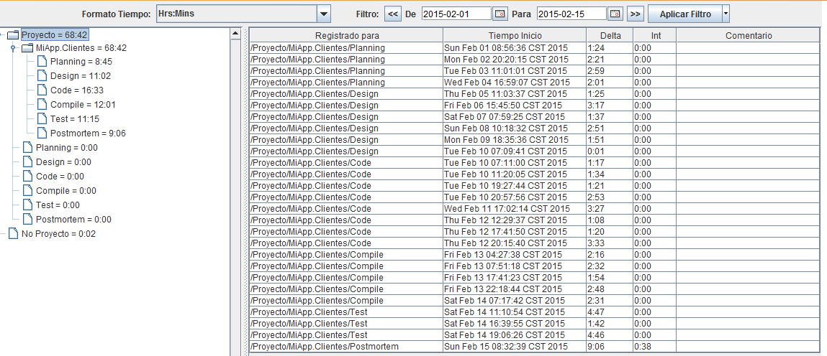

## Analisis de defectos

## 

## Tiempo en Fase a la Fecha

